**Database Application Programming**

**Project Status and Design Report**

|  |  |  |
| --- | --- | --- |
| **Topic:** | *Topic 4 Milestone 4* | |
| **Date:** | *March 23, 2019* | |
| **Revision:** | *1.3* | |
| **Team:** | 1. *N/A* | |
|  | |
|  | |
|  | |
| **Team Status:** | |  |  |  |  | | --- | --- | --- | --- | | **Task** | **Team**  **Member** | **Hours**  **Worked** | **Hours Remaining** | | *N/A* |  |  |  | |  |  |  |  | |  |  |  |  | |  |  |  |  | |  |  |  |  | |  |  |  |  | |  |  |  |  | |  |  |  |  | |  |  |  |  | |  |  |  |  | |  |  |  |  | |  |  |  |  | |  |  |  |  | | |
| **GIT URL:** | *https://github.com/tjames222/CST126_MILESTONE4* | |
| **Hosting URL:** | [https://foodforthoughtblogsd.azurewebsites.net](https://foodforthoughtblogsd.azurewebsites.net/)/Blog/homePage.php | |
| **Peer Review:** | *Y/N* | We acknowledge that our team has reviewed this Report and we agree to the approach we are all taking. |

**Supporting Design Documentation**

**Install Instructions:**

*Step by step instructions for setting up your database, configuring, and deploying/installing your application. This section should also include detailed instructions for what configuration files are required by your application, what configuration settings need to be adjusted for various runtime (development or production) environments, and where the files need to be deployed to. This section should also contain detailed instructions for how to clone your application source code from BitBucket and deploy the application to an externally hosted site.*

***TO RUN FILE FROM LOUDCOULD SUBMISSION***

*Step 1: Open file “MILESTONE3_Tim James_CST126”*

*Step 2: Open file “SOURCE CODE”*

*Step 3: Copy file “Blog”*

*Step 4: Paste file “Blog” to MAMP htdocs file folder*

*Step 5: Open web browser and paste:* <http://localhost:[port]/Blog/homePage.php>

***TO DOWNLOAD AND RUN FILE FROM GitHub SERVER***

*Step 1: Navigate to:* [*https://github.com/tjames222/CST126_MILESTONE3*](https://github.com/tjames222/CST126_MILESTONE32)

*Step 2: Download: Blog*

*Step 3: Follow instructions from step 3 from the loudcloud instructions above.*

***TO RUN FROM AZURE***

*Step 1: Navigate to:* [https://foodforthoughtblogsd.azurewebsites.net](https://foodforthoughtblogsd.azurewebsites.net/)/Blog/homePage.php

*Step 2: Enter Username:* ***tjames***

*Step 3: Enter Password:* ***password***

**General Technical Approach:**

*You should, in words, describe your approach and design here. You should also summarize any meeting notes, brain storming sessions, etc. that you want to retain thru the design of your project.*

My approach for this project is to build a blog/ news source that follows restaurants in a local area. The design will be light colors and clean sans serif fonts with modern forms and comment sections. The home page will essentially be a signup/ login area because this blog will be restricted to members only. Once logged in there will be news articles that members can read and comment sections under each post.

**Key Technical Design Decisions:**

*Any final technical design decisions, such as framework decisions etc., should be documented here. This should list the technology/framework, its purpose in the design, and why it was chosen.*

At this point in the project I am unaware of any specific frameworks or final technical decisions.

**ER Diagram:**

*Image file of your ER database diagram.*

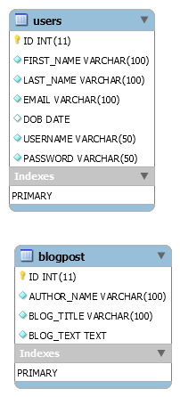

**DDL Scripts:**

*This should contain a link to Bitbucket where the DDL script can be downloaded from.*

*https://github.com/tjames222/CST126_MILESTONE4*

No DDL scripts at this time.

**Sitemap Diagram:**

*Image file of your Sitemap diagram.*

The sitemap.

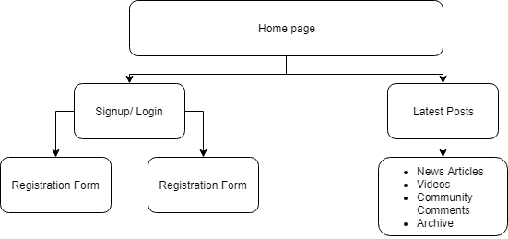

**User Interface Diagrams:**

*You should insert any wireframe drawings or white board concepts that were developed to support your application. If you have no supporting documentation please explain the rational why you are able to leave this section as N/A.*

No documentation at this point. Documentation will be created throughout the project.

**Other Documentation:**

*You should insert any additional drawings, storyboards, white board pictures, project schedules, tasks lists, etc. that support your approach, design, and project. If you have no supporting documentation please explain the rational why you are able to leave this section as N/A.*

